1.Create tables for sailor, boat and reserves

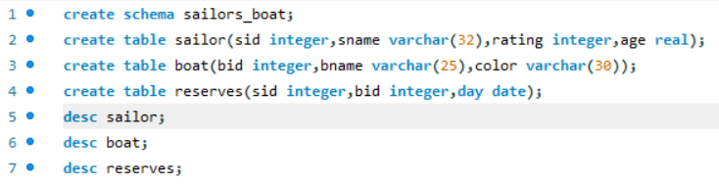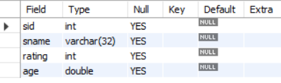

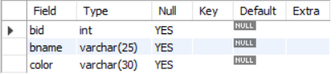

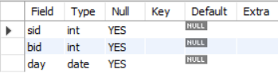

2.Insert 5 values each table

Sailor table:

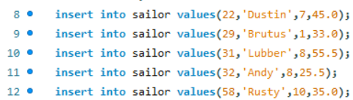

Boat table:

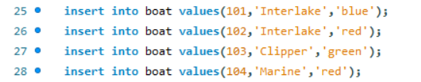

Reserves table:

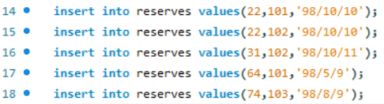

3.Display all records



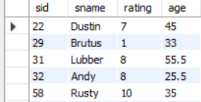



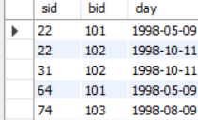



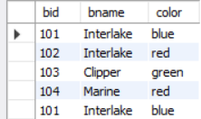

4.find the names and ages of all the sailors

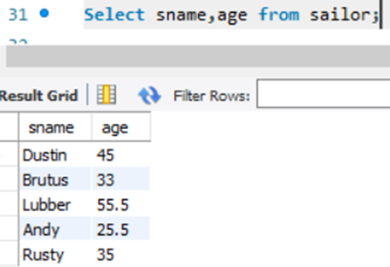

5.find all sailors with a rating above 8

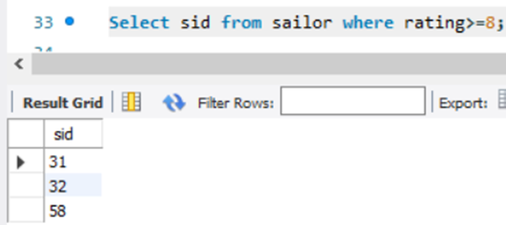

6.find sailors name with a rating above 7 & age above 25

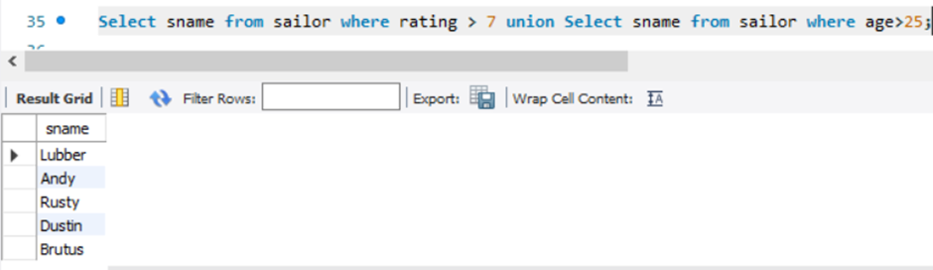

7.display all the names and colors of the boat

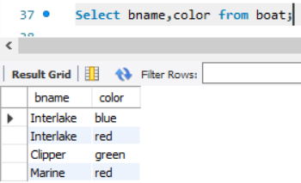

8.Find all the boats with red color

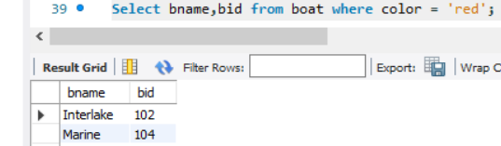

9.find the names of sailors who have reserved boat number 101

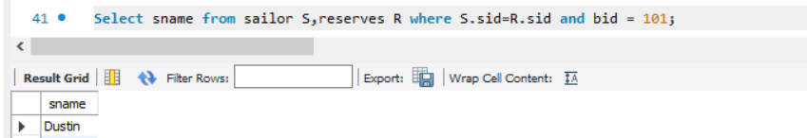

10.find the sids of sailor who have reserved pink boat

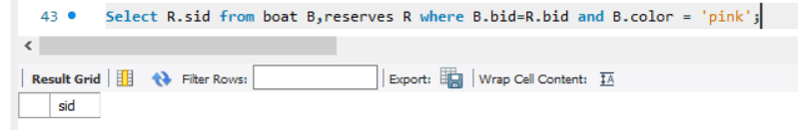

11.find names of sailors who have reserved red boat

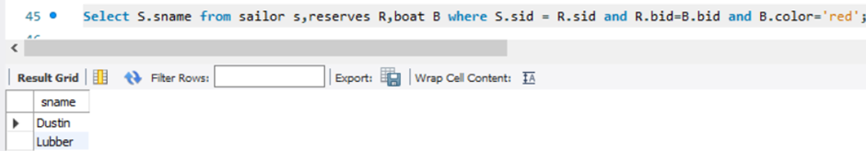

12.find the colors of boats reserved by some name (provide any name in the table)

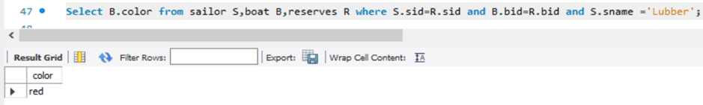

13.find names of the sailors who have reserved at least one boat

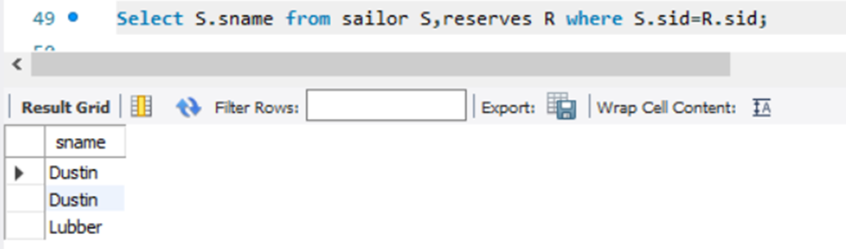

14.find names of the sailors who have reserved two different boats

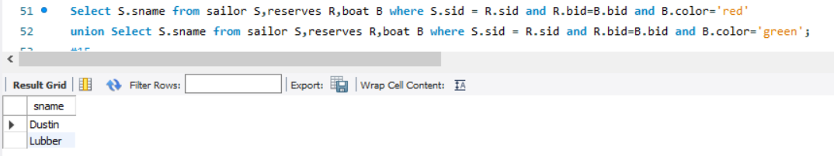

15.find the names of sailors who have reserved a red or a green boat

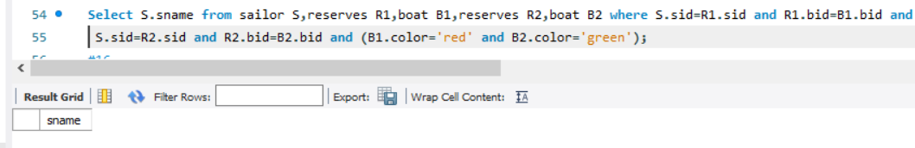

16.find the names of sailors who have reserved both a red and a green boat

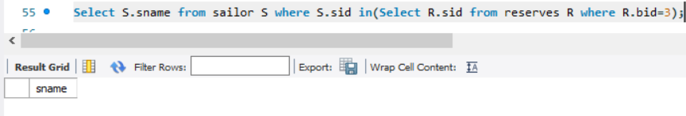

17.find the names of sailors who have reserved boat 3

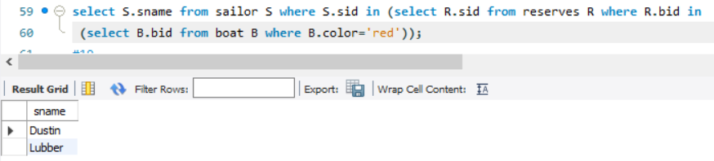

19.find the names of sailors who have not reserved a red boat(nq)

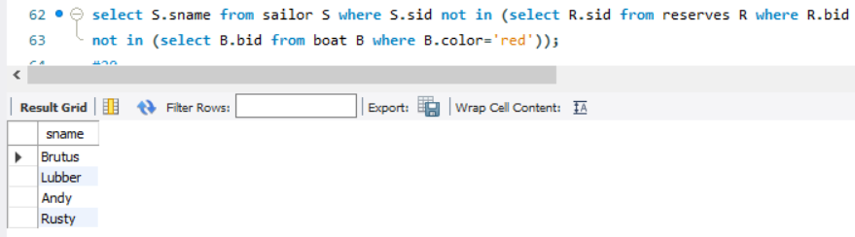

20.find the names of sailors who have reserved boat number 103(exists)

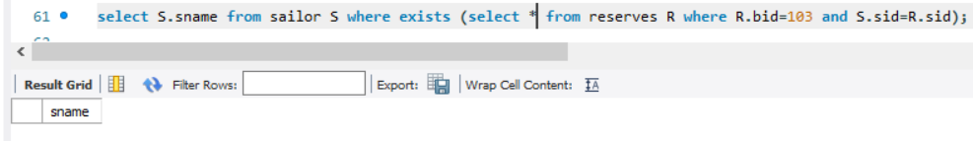

21.find sailors whose rating is better than some sailor called name

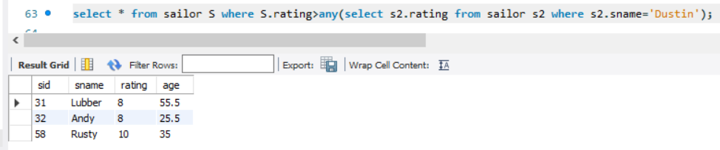

22.find sailors whose rating is better than every sailor called name

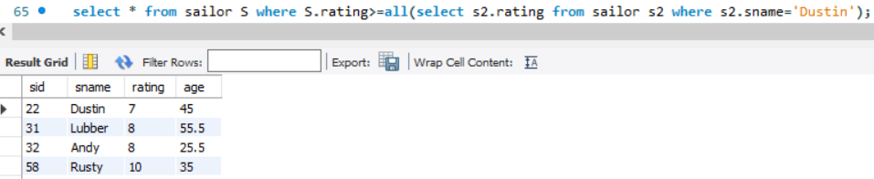

23.find the sailors with the highest rating

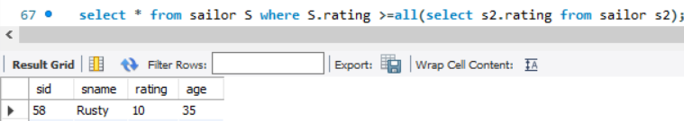

24.find the average age of all sailors

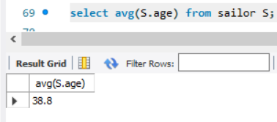

25.find the average age of sailors with a rating of 10

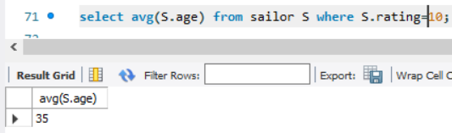

26.count the number of sailors

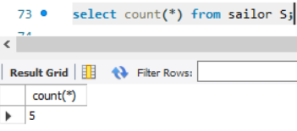

27.count the number of different sailor ratings



28.find the name and age of the oldest sailor

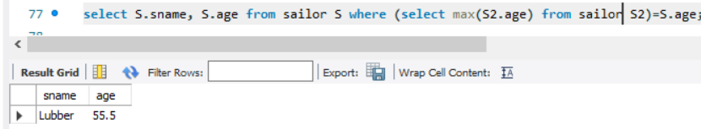

29.find the names of sailors who are older than the oldest sailor with a rating of 10

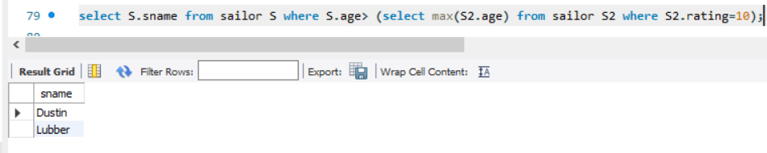

30.find the age of the youngest sailor for each rating level

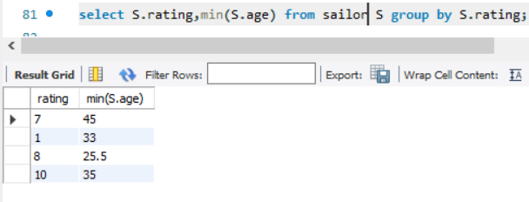

31.find the age of the youngest sailor who is eligible to vote (i.e., is at least 18 years old) for each rating level with at least two such sailors

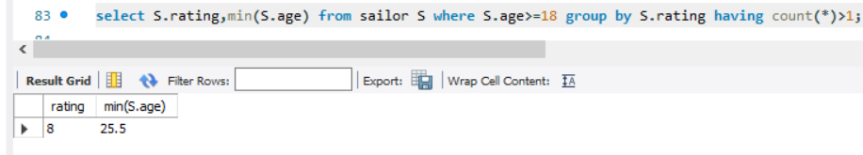

32.for each red boat, find the number of reservations for this boat

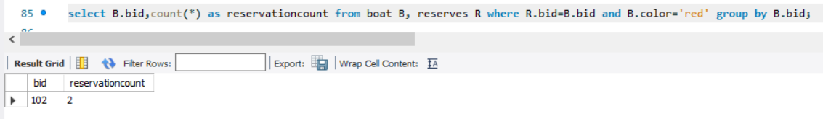

33.find all sailors name according to names

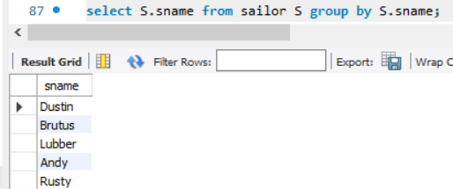

34.find all sailors details according to rating

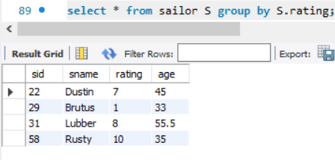

35. find all sailors details according to rating (highest first), if ratings are same then according to age

